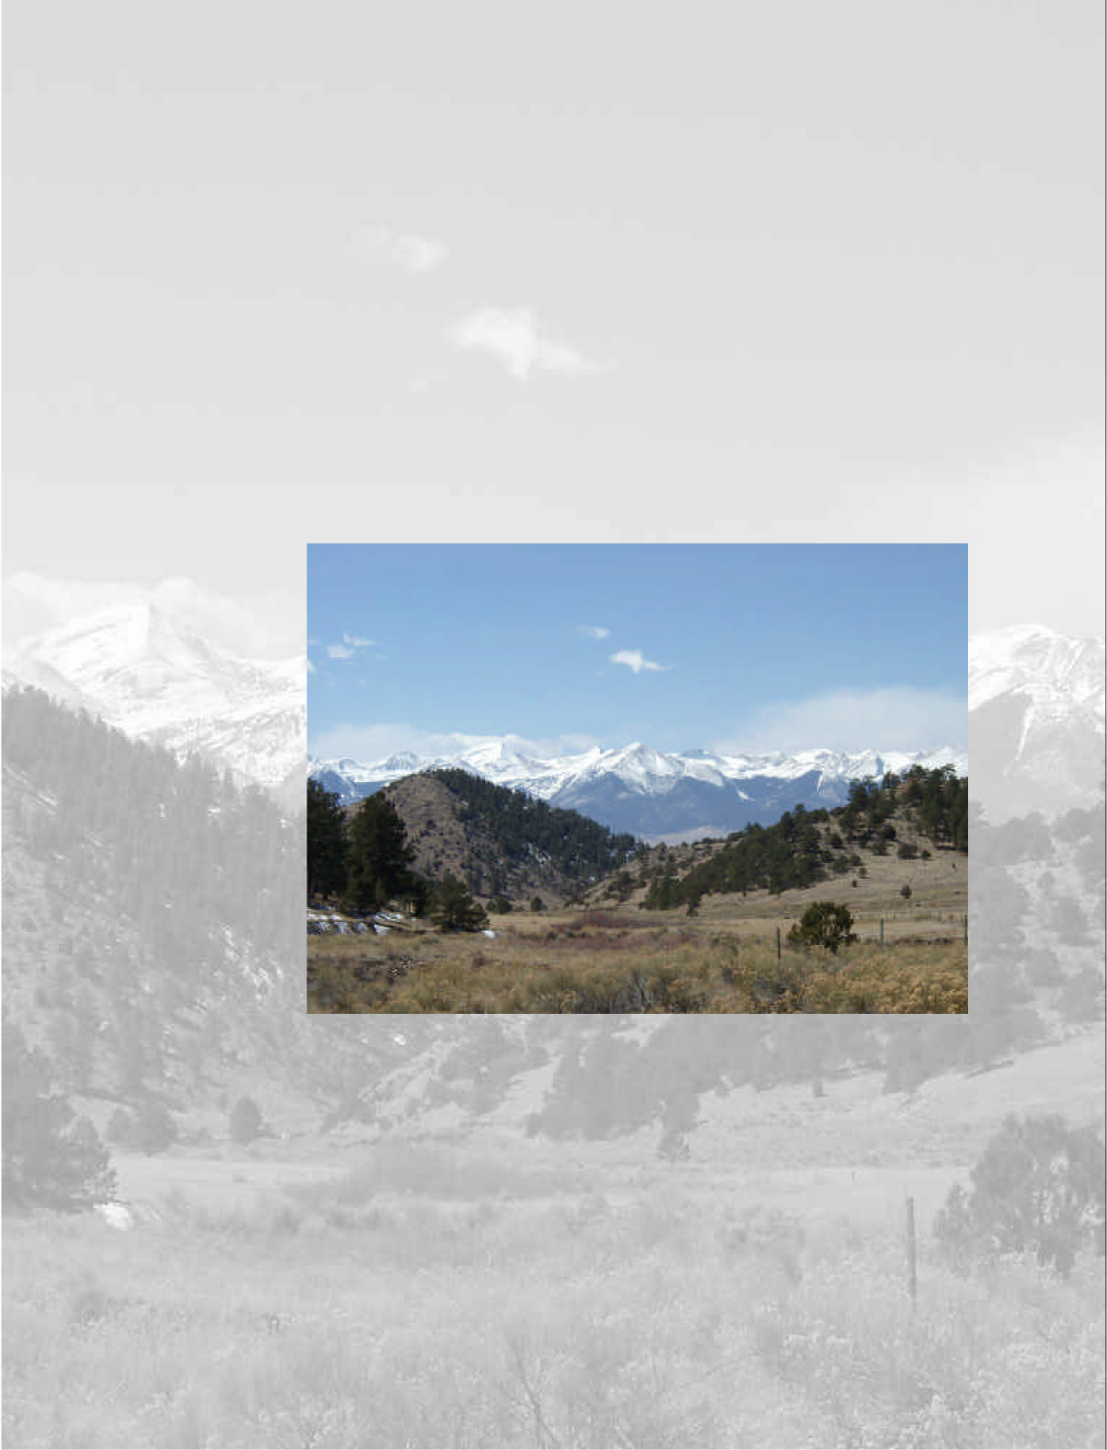
Custer County
Master Plan

Vision Statement
Custer County, home of one of Colorado’s most beautiful mountain landscapes, honors its rural, agricultural, mining, and western heritage, and seeks to connect its future with its past by protecting local values, preserving community assets, respecting property rights, accommodating managed growth and compatible economic development for all levels of society, and serving as a responsible steward of its spectular natural environment.

Table of Contents
Introduction 4
PURPOSE 4
PROCESS 4
USE OF THE PLAN 7
Planning Influences 9
ENVIRONMENTAL 9
LAND USE 14
SERVICES AND INFRASTRUCTURE 23
Plan Direction 30
PLANNING AREAS 30
ENVIRONMENT 33
COUNTY SERVICES 38
Appendix A: Glossary of Planning Terms 41
Appendix B: Bibliography 42
Appendix C: Adoption Resolution 45
Acknowledgments 46

List of Tables
Table 1. Historic Population 14
Table 2: Population Projections 14
Table 3: Public Land Use Acreage 15
Table 4: Private Land Use Acreage 15
Table 5. Selected Subdivision Activity 16
Table 6. Permit Activity 17
Table 7. Assessed Valuation 18
Table 8. Employment Projections 21
Table 9. Revenue/Expense Ratios 23

List of Maps
Figure 1. Location Map 8
Figure 2. Planning Influences Map 29
Figure 3. Plan Direction Map 40

Introduction

PURPOSE
The purpose of the Master Plan is to anticipate the inevitable growth-related challenges in Custer County and to help shape areas of future development within the County. The Master Plan is a written and visual document, sufficiently specific to allow general conformity with County zoning, subdivision and other land use regulations. It reflects a vision for future land use in Custer County which is acceptable to most of its citizens. It is an advisory document that respects property rights and establishes goals, policies and recommendations for action by the Board of County Commissioners, Planning Commission, Board of Zoning Adjustment, Regional Planning Commission, County staff and others.

This Master Plan will serve as a guide for Custer County. The decision makers will receive many requests to re-zone, to subdivide and to approve new development. They will be called on to draft new land use regulations. They will be pressured to depart from the rules they adopt. Inevitably, their decisions may involve conflicts among the goals set forth within the Master Plan.

When the Master Plan's goals conflict, the decision makers must find a balance which never loses sight of the County’s vision: honoring its rural, agricultural, mining and western traditions. "Rural" means different things to different people, but most agree that rural means individuals respecting property rights, neighbors respecting each other, fewer regulations, a less hectic or stressful way of life, and a safe place where families can live and grow. The goals of the Master Plan can be achieved when the County operates efficiently and responsively, with respect for private property and individual rights.

PROCESS
Despite many attempts over the past 33 years, Custer County has never adopted a master plan. In 1969, the Colorado State Planning Office, through an urban planning grant from the Department of Housing and Urban Development (HUD) under the provisions of Section 701 of the Housing Act of 1954, prepared a Sketch Plan for Custer County, Silver Cliff and Westcliffe. The simple, two-sided Sketch Plan plot outlined goals and objectives and described existing land use, transportation, and community facilities.
In proposing future land use, the Sketch Plan depicted five categories of uses: urban, agriculture, mountain residential, resort residential and open space. Although never adopted, the Sketch Plan served a very useful planning purpose for Custer County – the future land use categories provided the initial foundation for Custer County’s Zoning 1971 Resolution and its five zoning districts, later refined by local officials.

The second attempt to create a county master plan was initiated by the Upper Arkansas Council of Governments in 1975. Like the 1969 effort, the 1975 Custer County Comprehensive Plan was funded by a HUD planning grant. Unlike the 1969 Sketch Plan, the 1975 Comprehensive Plan provided in-depth detail of Custer County, with over 35 maps and illustrations organized into four plan sections addressing environmental setting, cultural characteristics, land use determinants, and Colorado House Bill 1041. Over 25 years later, much of the information within the 1975 Comprehensive Plan is still relevant as reference material.

In 1984, Custer County contracted with a planning consultant to prepare a “comprehensive area plan”, which included only approximately one-third of the county, primarily the central growth areas. At the time, proposed development of the Conquistador Ski Area, around the Lake De Weese area and the west Silver Airport area were anticipated to create significant growth pressure in the Wet Mountain Valley and upon the towns of Silver Cliff and Westcliffe. The 1984 Custer County Comprehensive Area Plan ultimately was not supported due to a desire to include the entire county in the comprehensive planning process, among other factors.

New growth pressures during the mid-1990’s spurred a “grassroots” initiative to develop a master plan. A local volunteer Master Plan Committee, appointed by the Regional Planning Commission, solicited input from local public officials and community groups, held numerous public meetings and created several drafts of a master plan. Approximately 250 people attended a workshop as part of the Custer County Community Forum on June 26, 1999, emerging with a top priority to adopt a master plan. The Custer County Regional Planning Commission adopted a version of a draft master plan in December 1999. After additional public review, two additional drafts (April 6, 2000 and August 23, 2000) were created and subsequently tabled by the Custer County Planning Commission. Both the April 6, 2000, and August 23, 2000 drafts included a vision statement and goals and strategies addressing land use, environment, government/citizen participation, economic development, transportation, education, mineral resources, water resources, and mineral development.

In November 2001, the County Commissioners hired MJ Landers & Associates, Inc., a planning consulting firm to facilitate additional public meetings and complete a master plan for adoption by the Custer County Planning Commission. Funded in part by an Energy Impact Assistance Grant from the Colorado Department of Local Affairs, the project also includes the preparation of a draft intergovernmental agreement between the County and the Towns of Silver Cliff and Westcliffe, an update to the County’s 1972 Subdivision Regulations, and the creation of a Plan User’s Workbook.

A steering committee comprised of the County Commissioners, the County Planning Commission, and the County Board of Zoning Adjustment guided the process to complete the County master plan, convening several work sessions to review and discuss material prepared by the consultant. Three sets of public meetings, held in Westcliffe and Wetmore during January, February and March 2002, serve as project milestones.

The process of preparing the current version of the Custer County Master Plan is designed to build upon the previous planning efforts in Custer County over the past 33 years. The effort begins with finding “areas of agreement” with the most recent master plan draft prepared in August 2000. Information collected from a variety of resources is compiled for analysis of environmental conditions, services and infrastructure, and land use, and includes work drawn from previous County plans, reports and related sources.
A revised vision statement is based on citizen direction to refine, clarify, and “wordsmith” the 2000 draft master plan vision statement, with additional input received from the Custer County Community Forum held January 19, 2002. A Plan Direction is crafted that reorganizes the goals and strategies of the August 2000 draft into refined goals, policies and actions, substantially based on established areas of agreement and the direction of County staff and the steering committee. This Custer County Master Plan document is presented for adoption by the Custer County Planning Commission.

USE OF THE PLAN
The Custer County Master Plan is considered an advisory document only and is not binding on the zoning discretion of Custer County. Although the plan is advisory, it serves as the basis for regulatory measures, primarily the Custer County Zoning Resolution and the Custer County Subdivision Regulations. The Custer County Master Plan serves as the foundation for future intergovernmental agreements, capital improvement programming, and detailed studies and programs; it can also be used as supporting documentation for pursuing grant-based activities.

The Custer County Master Plan should be referenced by County staff, the Regional Planning Commission, the Board of Zoning Adjustment, the Planning Commission and the County Commissioners when reviewing Zoning Permit applications, updating the Custer County Zoning Resolution and the Custer County Subdivision Regulations, working on intergovernmental issues with Silver Cliff, Westcliffe, and other agencies, outlining work programs, preparing annual budgets, and evaluating the County’s progress in meeting identified goals. The Custer County Master Plan should also be used to guide residents, landowners, and developers concerning land planning and community development objectives within Custer County.
Following this Section I: Introduction, Section II: Planning Influences outlines the environmental, land use, and service and infrastructure conditions within Custer County that establish the context for creating planning goals, policies and actions.

The Plan Direction, found in Section III, establishes six basic planning areas within Custer County. Each Planning Area has a set of Plan Directions that should be viewed as guidelines for public policy consideration and future land use decisions. Following the Plan Directions are goals, policies, and actions that are organized into three major themes: Environment, Land Use, and County Services. The Plan Directions and the associated goals, policies and actions should be used in conjunction with the Custer County Zoning Resolution and Custer County Subdivision Regulations to guide the appropriate location, character, type, and intensity of new development.

Although the Master Plan guides Custer County toward the future, it is also a “living” document adaptable to changes the future will bring. The Custer County Planning Commission should review the Master Plan annually, with a comprehensive review every five years.
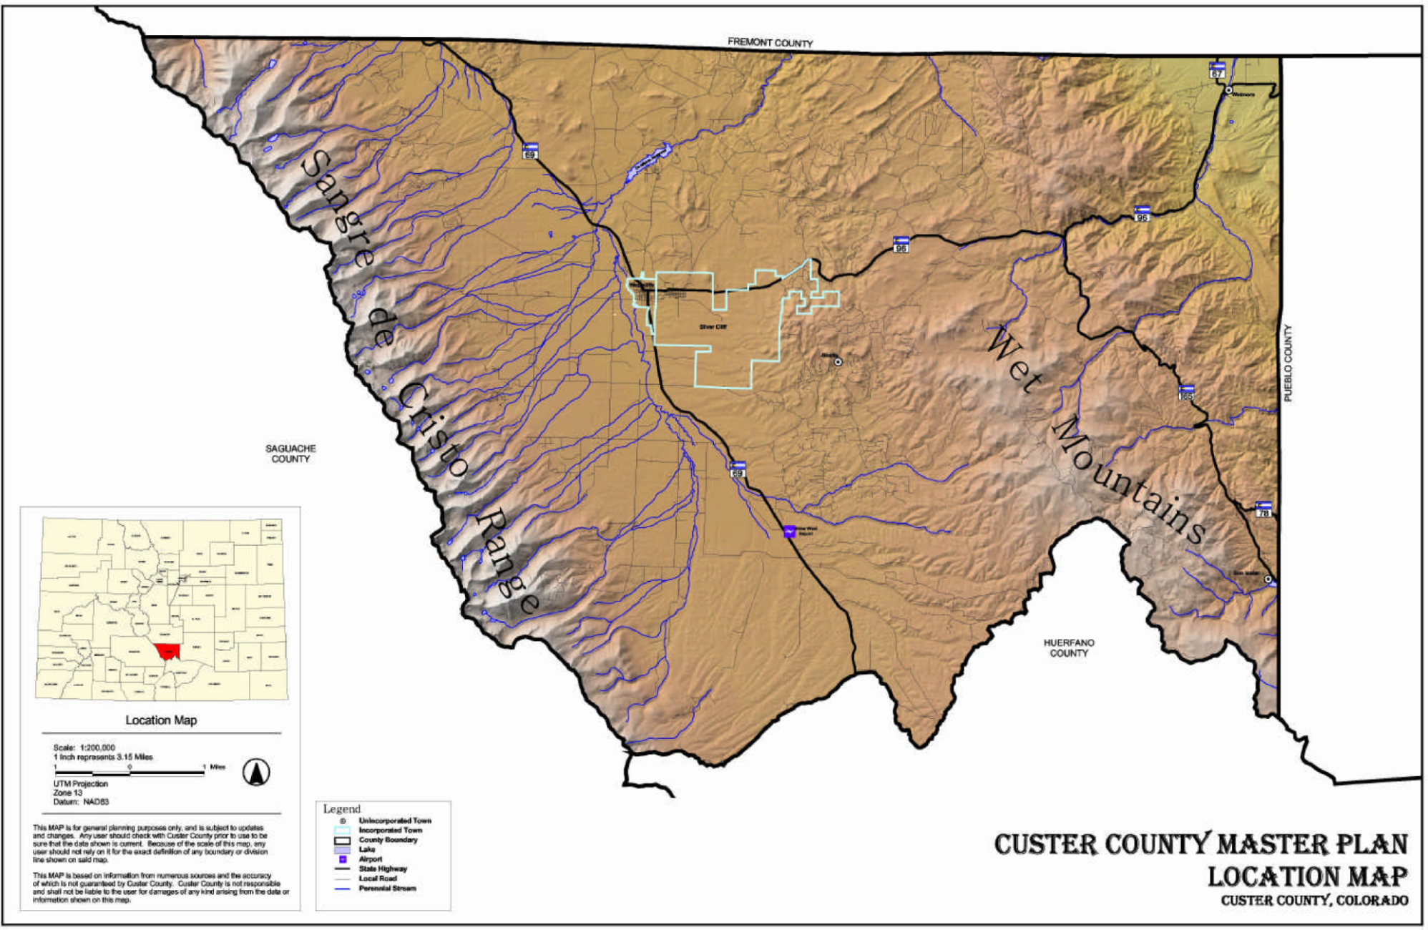
Figure 1. Location Map

Planning Influences

ENVIRONMENTAL
TOPOGRAPHY
Custer County encompasses 738 square miles of land area, extending from the high plains at its northeastern corner, across the Wet Mountains, into the Wet Mountain Valley and to the Sangre De Cristo Range. Elevation ranges from 6,081 feet in the northeastern community of Wetmore to the 14,294-foot summit of Crestone Peak in the Sangre De Cristo Range. Other peaks in excess of 14,000 feet framing the western boundary of the county include Crestone Needle, Kit Carson Mountain, and Challenger Point, with numerous additional peaks ranging from an elevation of 10,185 feet (Middle Knob) to 13,931 feet (Mount Adams). The Wet Mountain Valley lies at an elevation of approximately 8000 feet between the Sangre De Cristo Range and the Wet Mountains, which rise to an elevation of 11,784 feet at St. Charles Peak.

The natural topography of the landscape can either accommodate future land use activity or be a constraint to development. As slope increases, land generally becomes less suitable for development, with increased risks for wildfire and unstable soils, problems with road design, construction and maintenance, and access difficulties for fire protection equipment.
Slopes generally greater than 15 percent present specific challenges to development, with slopes in excess of 30 percent considered hazardous. Slopes in excess of 15 percent are generally found in the Wet Mountains and the Sangre De Cristo Range. Slopes less than 15 percent are generally found in the Wet Mountain Valley, surrounding foothills and within the incorporated communities of Westcliffe and Silver Cliff.

CLIMATE

Custer County has a high altitude, low humidity climate that fluctuates seasonally due to its varied topography. Based on climate data compiled since 1949, the average daily temperature in Custer County is 41.7 degrees Fahrenheit. The average January temperature at Westcliffe and Silver Cliff is 22.0 degrees Fahrenheit; the average July temperature is 63.4 degrees Fahrenheit. Other seasonal climate conditions in Custer County include average annual precipitation of 14.4 inches, an average snowfall of 92 inches, and an average wind speed, highest in April, at 10.4 miles per hour, although gusts occasionally exceed 100 miles per hour. The growing season is generally less than 90 days.
AIR QUALITY
Air quality is considered to be excellent, and the scenery and panoramic views of the landscape attract both residents and visitors to Custer County. Fugitive dust from unpaved roads and open lands, and smoke from ditch burning, is a periodic air quality concern.
GEOLOGY
The geology of Custer County is as varied as its terrain and climate. The oldest formations are found in the Wet Mountains, which are composed primarily of Precambrian metamorphic felsic and hornblendic gneisses derived from volcanic rocks. The Sangre De Cristo Formation of the Sangre De Cristo Range consists of arkosic conglomerate, sandstone and siltstone from the Permian and Pennsylvanian eras. The Wet Mountain Valley is composed of unconsolidated gravel and alluvium deposits from the Pleistocene era; siltstone, sandstone and conglomerates from the Miocene era. Lava deposits and ash flows from the Oligocene era are also found in the foothills of the Wet Mountain Valley.

As defined by the Colorado Geologic Survey, a geologic hazard is “a geologic phenomenon which is so adverse to past, current or foreseeable construction or land use as to constitute a significant hazard to public health and safety or to property.” Potential geologic hazards in Custer County include ground subsidence in the old Silver Cliff, Ilse, Querida and Rosita mining districts, and rock falls, mudslides and avalanches, particularly on slopes in excess of 30 percent. While mining for minerals is not presently economical, the potential for mining sand and gravel in the Wet Mountain Valley to support construction demand, and the existence of oil and gas resources in the northeast portion of Custer County, warrant consideration for developing plans to mitigate operational impacts.
SOILS
There are seven soil units in Custer County mapped by the Natural Resources Conservation Service. Soils characteristics in the San Isabel National Forest are not described or mapped by the Natural Resources Conservation Service. The seven soil units and their general characteristics are described as follows:
- Leadville-Troutville-Ula: Moderately deep and deep, well drained and somewhat excessively drained, gently sloping to extremely sloping soils, generally located on benches, fans, foot slopes, mountainsides and stream terraces abutting the eastern edge of the San Isabel National Forest in the Sangre De Cristo Range on the western side of Custer County.
- Norriston-Gelkie-Libeg: Deep, well drained and somewhat excessively drained, gently sloping to very steep soils, generally located on fans and terraces in the foothills of the Sangre De Cristo Range.
3) Venable-Alvarado: Deep, somewhat poorly drained, nearly level to moderately steep soils, generally located on fans, terraces, and foot slopes and in swales and drainages of the Wet Mountain Valley.
- Feltonia-Coutis-Silvercliff: Deep, well drained, gently sloping to very steep soils, generally located on fans, terraces, foot slopes, and terrace edges and in drainage ways of the Wet Mountain Valley.
- Rogert-Woodhall-Boyle: Shallow and moderately deep, well drained, gently sloping to very steep soils that have dark colored surface layer, generally located on hills, hilltops, uplands, ridges, and mountainsides in the Wet Mountains.
- Redfeather-Wix: Shallow and moderately deep, well drained, gently sloping to very steep soils that have a light colored subsurface layer, generally located on hilltops, side slopes and mountainsides in the Wet Mountains.
- Granile-Peeler-Lake Creek: Moderately deep and deep, well drained, moderately sloping to extremely steep soils, generally located on mountainsides and mountain foot slopes in the Wet Mountains.

Soil properties may pose constraints on land use or development activity. Poorly drained soils on low terraces with a seasonally high water table, such as those found in the Venable-Alvarado soil unit west of Westcliffe, may be best suited for agricultural uses, and pose limitations on other types of land use. Limitations on placement of septic systems and dwellings (with or without basements) are typical in areas with adverse soil properties (e.g., shrink/swell potential), which are present throughout Custer County.
VEGETATION
The natural vegetation within Custer County is dominated by diverse grasslands and woodlands. Blue grama grasslands of the high plains give way to pinon and juniper shrubs near Wetmore to the woodlands of the Wet Mountains, with its stands of ponderosa pine, Douglas fir, white fir, blue spruce and aspen trees. The high mountain grasslands of the Wet Mountain Valley vary from large grass expanses to pinon and juniper shrubs. More lower mountain woodlands west of the valley floor rise to sub-alpine woodlands with stands of spruce, fir and aspen mingling with Thurber’s fescue meadows, capped by alpine regions above timberline, with sedges and numerous forbs.
Non-native noxious weeds in Custer County include Leafy Spurge and three varieties of Knapweed.
A ten-acre site with rare plant habitat near Brush Creek is the only site in Custer County registered with the Colorado Natural Area Program. The Colorado Natural Area Program registration is similar to a conservation easement, protecting sites with a high quality feature of statewide significance, such as native or rare plant communities.
Generally, the potential for wild land fire exists on dry, vegetated hillsides. Although wildland fire hazard mapping is not available yet in Custer County, the State Forester is available to work with homebuilders in rural areas to mitigate wild land fire hazards using “defensible space” and other techniques. The Bureau of Land Management (BLM) is also proposing to create fire fuel breaks and conduct prescribed burns in select areas. The health of the forests in Custer County also affect wild land fire potential, with large outbreaks of pine beetle, dwarf mistletoe, excessive accumulations of dead trees, and overly dense small trees indicators of poor forest health. Poor forest health and large accumulated fuel loads may threaten adjoining lands and developed residential communities.
WATER
Custer County is situated in the Arkansas River watershed, with five major stream basins: Grape Creek, Texas Creek, Oak Creek, Hardscrabble Creek, and the St. Charles River. Grape Creek, fed by snowmelt from the Sangre De Cristo Range and the Wet Mountains, is the largest stream basin in Custer County, covering approximately 273,000 acres, followed by the Hardscrabble Creek basin (77,500 acres), Texas Creek basin (54,000 acres), St. Charles River basin (46,000 acres), and Oak Creek basin (21,000) acres.
Custer County does not have Federal Emergency Management Agency (FEMA) flood hazard mapping. Regardless of the lack of flood hazard mapping, development along streams and dry wash channels is not recommended in order to minimize increases in downstream flood elevation, potential life or safety hazards, and property damage.
Custer County is covered by approximately 520 acres of lakes and reservoirs. The 208-acre De Weese Reservoir dams Grape Creek and has a capacity of 2,783 acre-feet of water. Another 25 lakes are located in Custer County, the majority of which are in the Sangre De Cristo Range.
One notable exception is the 36 acre Lake San Isabel, located in the Wet Mountains in southeastern Custer County.
Approximately 425 thousand acre-feet of water recharge the watershed in Custer County, primarily from the Sangre De Cristo Range. An estimated 1.5 million acre-feet of groundwater is stored within the upper1 00 feet of the Wet Mountain Valley. The groundwater is recharged by lakes, streams and return flows, although withdrawals are increasing consistent with an increase in active wells and demand on existing municipal wells.
During the past fifteen years, the Upper Arkansas Water Conservancy District (UAWCD) and the United States Geological Survey (USGS) have been monitoring wells recording data regarding groundwater quantity, but not quality. The Arkansas River watershed has a water quality ranking of “3” on a scale of “1” to “6”, indicating less serious water quality problems and a low vulnerability to toxic pollutants. A new hydrological study is underway by the USGS and the UAWCD to adequately determine groundwater quality and quantity, monitoring approximately 40 wells in the Wet Mountain Valley, 10 wells in the Wetmore area, and 10 wells in the San Isabel area.
The UAWCD provides temporary supplemental water to the Round Mountain Water and Sanitation District as well as other entities in Custer County, although Custer County is not included in a water augmentation plan for the UAWCD.
WETLANDS
Wetlands generally are located in flat areas associated with streams in the Wet Mountain valley. The US Fish and Wildlife Department publishes National Wetland Inventory Maps that need to be verified by the US Army Corp of Engineers and/or private wetland consultants for accuracy. Any development in, or disturbance of defined jurisdictional wetlands is subject to Section 404 of the Clean Water Act as administered by the US Army Corp of Engineers.
WILDLIFE
Custer County has abundant wildlife - the Colorado Division of Wildlife (DOW) identifies 73 species of birds and 38 mammal species in Custer County. Mule deer and elk habitat is found throughout the county. Bobcat, mountain lion and black bear habitat is found in the Sangre De Cristo Range and the Wet Mountains. Big horn sheep are found at higher elevations in the Sangre De Cristo Range and the Wet Mountains. Antelope habitat is mapped by DOW north of De Weese Reservoir, although antelope are found throughout the country. Federally listed threatened or endangered species include the American peregrine falcon, bald eagle, greenback cutthroat trout, meadow jumping mouse, Mexican spotted owl, southwestern willow flycatcher, and whooping crane. A grant from Frontier pathways recently funded a wildlife viewing area four miles west of Wetmore.
Wildlife is impacted by reduction of habitat and barriers to movement, generally resulting from land subdivision, building, road and fence construction.
For example, areas where wildlife forage is inadequate could result in dwindling herd sizes through starvation, and destruction of remaining habitat by overgrazing. Problems associated with wildlife displacement can be significantly reduced if the potential for wildlife impact is addressed during the development review process. Custer County requires a Wildlife Review for any potential PUD or subdivision development.

LAND USE
CONTEXT
Custer County is located in south central Colorado and is bordered by Fremont County to the north, Pueblo County to the east, Huerfano County to the south, and Saguache County to the west. Originally occupied by the Ute Indians, explored by Zebu lon Pike, settled by German colonists, and named after the famous cavalry leader General George A. Custer, Custer County was established on March 9, 1877. Over the past 125 years, Custer County has become a special place with unique qualities and challenges which ultimately influence land use and development decisions.
Like many Colorado counties, the population of Custer County has fluctuated with “boom and bust” economies. The surge of silver and gold mining activity in the 1870’s
brought a population to Custer County more than double what exists today. By 1890, the population dropped as mining claims were played out. Cattle ranching became the mainstay of the economy, as difficult as it was to get access to markets after the railroad was abandoned in 1937. Population continued to decline between 1940 and 1970. Between 1970 and 1990, population steadily increased with the growth of tourism and a relatively stable state economy. However, from 1990 to 2000 Custer County grew 82 percent, becoming the fourth fastest growing county in Colorado, with its spectacular natural setting attracting new residents enjoying a strong state and national economy focused on information technology, recreation, tourism and services. The largest surge in population is among affluent individuals aged 45 to 64.
Population is expected to continue to grow, although not at rates experienced during the 1990’s.
Table 1. Historic Population
Historic Population
1880 | 1890 | 1900 | 1910 | 1920 | 1930 | 1940 | 1950 | 1960 | 1970 | 1980 | 1990 | 2000
7,967 | 2,970 | 2,937 | 1,947 | 2,172 | 2,124 | 2,270 | 1,573 | 1,305 | 1,120 | 1,528 | 1,926 | 3,503
Source: U.S. Census Bureau; 2001

Table 2: Population Projections
Population Projections
2005 | 2010 | 2015 | 2020 | 2025
4,297 | 5,098 | 5,956 | 6,769 | 7,569
Source: Colorado Department of Local Affairs; 2001

INCORPORATED TOWNS
Two statutory towns, Silver Cliff and Westcliffe, are centrally located adjacent to each other with Westcliffe serving as the County seat.
Silver Cliff is one of Colorado’s oldest mining communities, originating in 1879. Once one of Colorado’s largest towns in terms of population, Silver Cliff is now one of Colorado’s largest towns in terms of land area, having annexed over 7,000 acres in 1973. The 2000 Census population of Silver Cliff is estimated to be 512 persons, a 59 percent increase since 1990. In January 2002, Silver Cliff adopted its first Master Plan and Subdivision Regulations.
Westcliffe, incorporated in 1887, serves as the economic, cultural, and government center of Custer County. Originally conceived as a speculative development for a railroad terminus, Westcliffe evolved as a ranching
community. The 2000 Census population of Westcliffe is estimated to be 417 persons, a 34 percent increase since 1990. The Town of Westcliffe adopted its first Master Plan in December 2000, and updated its Land Use Code in February 2001.
LAND USE, ZONING AND SUBDIVISION
Custer County is primarily a rural county, with urban uses generally located within the incorporated towns of Silver Cliff and Westcliffe. Of Custer’s County’s 473,600 acres, 188,988 acres, or 39.9 percent is public land, and 284,612 acres, or 60.1 percent, is private land.
Public land is managed by the United States Forest Service (USFS), BLM, State of Colorado and the local governments of Custer County, Silver Cliff and Westcliffe. USFS lands include portions of the San Isabel National Forest, the Greenhorn Wilderness Area, and the Sangre De Cristo Wilderness Area.

Table 3: Public Land Use Acreage
Public Land Number of Acres Percentage of Total
U.S. Forest Service | 163,647 | 86.59%
Bureau of Land Management | 14,776 | 7.82%
State of Colorado | 10,165 | 5.38%
Local Government | 400 | 0.21 %
TOTAL | 188,988 | 100%
Source: Custer County Assessor’s Office; 2001
Table 4: Private Land Use Acreage
Private Land Use Number of Acres Percentage of Total
Agriculture | 212,502 | 74.66%
Residential | 23,670 | 8.32%
Commercial | 779 | 0.27%
Industrial | 21 | 0.01 %
Vacant | 41,876 | 14.71%
Other | 5,764 | 2.03%
TOTAL | 284,612 | 100%
Source: Custer County Assessor’s Office; 2001

Agricultural land comprises approximately 75 percent of private land in Custer County. The 2001 assessed value of agricultural property is over $10 million. Custer County adopted a Right to Ranch and Farm policy in 1998 to protect the viability of agricultural land use activities. Since 1998, organizations working to preserve over 10,000 acres of contiguous agricultural lands in Custer County have received grants from Great Outdoors Colorado ($400,000), and the Colorado Conservation Trust ($320,000). The San Isabel Foundation and the Rocky Mountain Elk Foundation are also the recipients of a $10,000 grant and a $13,300 grant, respectively, from Great Outdoors Colorado. The grants are intended to be used for the purchase of conservation easements and transaction costs. Currently, conservation easements held by the Palmer Foundation, Colorado
Division of Wildlife, Colorado Cattleman’s Agriculture Land Trust, San Isabel Foundation and Rocky Mountain Elk Foundation exist on 7,235 acres of land in Custer County.
Table 5. Selected Subdivision Activity
Subdivision | Number of Lots | Number Built | Percentage  Built-Out
Antelope Valley | 187 | 44 | 23.53%
Blumenau | 315 | 62 | 19.68%
Brush Creek Estates | 48 | 32 | 66.67%
Bull Domingo Ranch | 347 | 103 | 29.68%
Centennial Ranch | 412 | 47 | 11.41%
Cristo Vista | 217 | 46 | 21 .20%
Cuerno Verde The Pines | 528 | 63 | 11 .93%
Dilley Ranch | 83 | 15 | 18.07%
Eastcliffe | 145 | 51 | 35.17%
McKinley Mountain Ranch | 46 | 19 | 41.30%
Mountain Springs Country Estates | 23 | 12 | 52.17%
Ponderosa Park | 44 | 29 | 65.91 %
Rosita Hills | 380 | 83 | 21.84%
Silver Cliff Heights | 569 | 142 | 24.96%

The majority of residential and vacant land is located in over 120 platted subdivisions in Custer County. Of 8,681 tracts of land 80 acres or less in size, 5,934, or 68 percent, are vacant. The following are the build-out percentages on 14 selected subdivisions, as of 11/15/2001:
Commercial property is predominantly located in the towns of Silver Cliff and Westcliffe. Retail (merchandising) property has a 2001 assessed value of over $1 million, as does special purpose commercial property, followed by offices ($983,010), warehouses and storage ($844,950) and lodging ($633,020). By comparison, very little industrial development exists in Custer County, with a total 2001 assessed value of only $132,380. Other private land use includes property used for natural resource, recreational, and non-profit activities. Mining claims, prevalent in the Silver Cliff area, account for a significant portion ($470,580) of the 2001 assessed value of natural resources, roughly equivalent to the 2001 assessed value of recreation property ($404,590).
Custer County does not have a building code, although State electrical and plumbing, and State and County septic codes must be followed. A zoning permit is required for all dwelling structures, and all accessory structures greater than 100 square feet in size. Custer County recently adopted a Compliance Inspection process that must be met before any dwelling owner completes their zoning permit requirements. The following chart tracks zoning permit and septic permit activity in Custer County since 1994:

Table 6. Permit Activity

Source: Custer County Planning and Zoning Department; 2009

Table 7. Assessed Valuation
2001 Assessed Valuation
Property Type: | Assessment:
Vacant Land | $ | 17,941,740
Residential | $ | 21,574,470
Commercial | $ | 5,474,700
Industrial | $ | 132,380
Agricultural | $ | 10,266,680
Natural Resources | $ | 554,240
Producing Mines | $ | 0
Oil and Gas | $ | 0
State Assessed | $ | 3,453,400
Assessed Value | $ | 59,397,610
Exempt Valuation | $ | 3,919,700
Total Valuation | $ | 63,317,310
Source: Custer County Assessor’s Office; 2002

Agriculture, residential, commercial, industrial, natural resource, and other land uses found within Custer County can best be described based on the zoning district within which they are permitted. All zoning districts allow agricultural and residential uses as a “use by right”, meaning that no additional approvals are required beyond a zoning permit. Only one single-family dwelling is permitted per parcel in any district, unless otherwise approved.
Special Use Permits (SUP’s) are required for commercial, industrial, natural resource and other uses. The Custer County Zoning Resolution also requires that all structures be setback a minimum of 50 feet from property lines of lots one acre or larger, with a maximum building height not to exceed 25 feet from the highest point of grade.
Custer County’s zoning districts were adopted in 1971 and were based on five physiographic regions, as follows:
Zoning District I:
Grape Creek District
The Grape Creek Zoning District is located in the Wet Mountain Valley, generally due west of Westcliffe, SH 69 and Grape Creek. The Grape Creek Zoning District is generally a rich alluvial environment dominated by agricultural land uses, including irrigated lands, meadow hay lands, and grazing lands along the Grape Creek drainage. As such, the Grape Creek Zoning District is intended to have a low population density and to remain agricultural in character, with a minimum lot size of 80 acres. Very few subdivisions exist in the Grape Creek District.
Zoning District II:
Sangre De Cristo Zoning District
The Sangre De Cristo Zoning District is located along the Sangre De Cristo Range, and is generally a high mountain environment with substantial public lands, agricultural and residential uses, with a minimum lot size of 35 acres.
Numerous 35-acre subdivisions exist in the foothills of the Sangre De Cristo District. The old Conquistador Ski Area, two public campgrounds and numerous hiking trails are also located in the Sangre De Cristo Zoning District, including the popular Rainbow Trail.

Zoning District III:
Wet Mountain Zoning District

The Wet Mountain Zoning District is located east of the Foothills Zoning District, in the Wet Mountains generally extending to County Road 387 and the eastern boundary of the San Isabel National Forest. The Wet Mountain Zoning District is generally a forested mountain environment with substantial public lands and limited agricultural and residential uses, with a minimum lot size of 10 acres. Several public campgrounds and hiking trails are located in the Wet Mountain Zoning District, as is Bishop’s Castle, a popular tourist attraction located between San Isabel and McKenzie Junction along SH 165.
The settlement of San Isabel is also located in the Wet Mountain District along SH 165. Commercial uses related to recreational activities associated with nearby Lake San Isabel, and residential uses with a minimum lot size of less than 10 acres, exist in the San Isabel area. Besides San Isabel City, subdivisions in the San Isabel area include Willow Creek Camp, God’s Country Estates, Gold Hill Addition, Wonder Trail Addition, and Lake View Addition.
Zoning District IV:
Foothills Zoning District

The Foothills Zoning District is located in portions of the Wet Mountain Valley and the Wet Mountains, and is generally a sage-covered environment with numerous patented mining claims and approved residential subdivisions. Over 30 subdivisions in the Foothills Zoning District are platted with lots of at least 35 acres in size, although the minimum lot size in that District is five acres. The largest subdivision is Silver Cliff Heights, located in the northern portion of the Foothills District. Several large 35-acre subdivisions originally in the Foothills Zoning District, such as Bull Domingo Ranch and Centennial Ranch, have been rezoned to Zoning District II.
The community of Rosita is located at the junction of CR 323, CR 328 and CR 329. The Rosita Townsite, as of November 15, 2001, is only 14 percent built out, with approximately 300 vacant lots. Numerous other partially developed subdivisions are in the Rosita area, including Blumenau, Cristo Vista and Rosita Hills. Also located in the Foothills Zoning District is Lake De Weese Reservoir, with its related residential and recreational development. Lake De Weese Resort is the major subdivision in the Lake De Weese area, although several other smaller subdivisions include Lakeshore Acres, Sierra City and Mountain View. The Silver West Airport is a County airport and has related subdivision development, with no enforced Airport Influence Area.
Zoning District V:
Hardscrabble Zoning District
The Hardscrabble Zoning District, located in the northeastern portion of Custer County between the Wet Mountains and the County boundary, is generally high plains and rolling terrain with concentrated development in the Wetmore area, with a minimum lot size of 10 acres. Due to its similarity with the 10-acre minimum lot size requirement with the Wet Mountain Zoning District, the County has recently integrated the Hardscrabble Zoning District with the Wet Mountain Zoning District as part of its updated Zoning Resolution.
Wetmore is located in the Hardscrabble Zoning District at the intersection of SH 96 and SH 67, approximately 26 miles west of the city of Pueblo. Commercial uses, and residential uses with minimum lot sizes less than 10 acres, exist in the community of Wetmore. Major subdivisions west of Wetmore include T.V. Hills, Adobe Creek Ranch, and King Mountain Estates. In the Greenwood area south of Wetmore, subdivisions include Greenwood Tracts and Hardscrabble Homesites.
HOUSING
According to the 2000 Census, Custer County has a total of 2,989 housing units, of which 1,480, or approximately 50 percent, are owner-occupied. Another 1,315 dwelling units, or 44 percent, are seasonal or “second homes”, leaving 194 units (6 percent) vacant. The total number of housing units in Custer County has increased almost 35 percent since 1990, while the number of seasonal housing units has increased only 5.1 percent since 1990.
The total number of households (owner-occupied units) almost doubled since 1990, an increase of 92 percent. The average household size is 2.36 persons per dwelling unit. 73 percent of households have families, with an average family size of 2.77 persons per dwelling unit.
ECONOMIC DEVELOPMENT
The top five economic sectors in Custer County, based on employment, are wholesale and retail, government, construction, agricultural products, and services. Employment growth is projected to steadily increase.
With the exception of residentially zoned areas in Silver Cliff and Westcliffe, all of Custer County is in the Upper Arkansas Enterprise Zone (UAEZ). The following tax incentives are available to qualified businesses in the UAEZ:
- Investment Tax Credit
- New Business Facility Job Credits
- State Sales and Use Tax
Exemption for Manufacturing and Mining Equipment
- Research and Development Tax Credit
- Tax Credit for Private
Contributions to enterprise Zone Administrators
- Tax Credit for the rehabilitation of Vacant Commercial Buildings
- Qualified Job Training Program Investment Credit

Table 8. Employment Projections
Employment Projections
 | 2000 | 2005 | 2010 | 2015 | 2020 | 2025
Total Jobs | 1,469 | 1,739 | 1,944 | 2,124 | 2,433 | 2,690
Source: Colorado Department of Local Affairs; 2001

HISTORIC PRESERVATION
Historic preservation efforts in Custer County are led by several organizations, including but not limited to the Custer Chapter of the Fremont-Custer Historical Society, All Aboard Westcliffe, Friends of Beckwith Ranch, and Frontier Pathways. Since designation of SH 96 in 1998 as a Scenic and Historic Byway, over $500,000 of private donations, state and federal grants have funded numerous projects in Custer County. Projects have included renovation of the Historic Beckwith Ranch, an interpretive center in the “Westcliff” School, stabilization of the Mingus Homestead, and a historical survey of the Wet Mountain Valley.
The following sites in Custer County are listed on the National Register of Historic Places:
- Mingus Homestead, in the San Isabel National Forest, Fairview vicinity
- Beckwith Ranch, 64159 SH 69, north of Westcliffe
- Hope Lutheran Church, 310 South 3rd Street in Westcliffe
- Kennicott Cabin, 63161 SH 69, north of Westcliffe
- National Hotel/Wolff Building, 210 South Second Street in Westcliffe
- Westcliffe Jail, 116 North Second Street in Westcliffe
- “Westcliff” School, 116 South
- Fourth Street in Westcliffe
- Willows School, on Willow Lane between Muddy Lane and Schoolfield Lane

In addition to the sites listed on the National Register of Historic Places, the following sites are on the Colorado State Register of Historic Places:

- Original Silver Cliff Town Hall and Engine House, 606 Main Street in Silver Cliff
- D&RG Engine House, Rosita Avenue west of Second Street in Westcliffe
- Mercier House, 215 South
- 6th Street in Westcliffe

SERVICES AND INFRASTRUCTURE
GOVERNMENT
Custer County provides an array of services to county taxpayers, normally categorized as public works, public safety, social services, and administration. The County administrative offices are located in the Custer County Courthouse on ₆th Street in Westcliffe. The courthouse also houses the Colorado State University Extension Office. The elected County Commissioners and the appointed Planning Commission, Regional Planning Commission, and Board of Zoning Adjustment each conduct meetings at the courthouse, addressing land use issues.
Silver Cliff and Westcliffe are statutory town governments that provide services to residents within their incorporated boundaries. Both Silver Cliff and Westcliffe have administrative offices at their Town Hall located on Main Street in their respective communities. Each Town also has an elected Board of Trustees and an appointed Planning Commission that addresses community land use issues.
Several special districts operate in Custer County, including the Upper Arkansas Water Conservancy District, the Round Mountain Water and Sanitation District, the West Custer County Hospital District, the West Custer County Library District, the Wet Mountain Fire Protection District, and the Consolidated C-1 School District.
The majority of property taxes assessed in Custer County
(56 percent) go to the Consolidated C-1 School District, followed by County services (25 percent), various special districts (18 percent), and the Towns of Silver Cliff and Westcliffe (1 percent). Conversely, the majority of sales tax revenue flows to the towns, where retail services are primarily located.
A Cost of Community Services study sponsored by the San Isabel Foundation, Custer Heritage Committee, Sonoran Institute and American Farmland Trust in 2000 measured the impact that various land uses have on Custer County’s tax base. The study found that agricultural, commercial and industrial land generates more tax revenue than services provided, whereby residential land generates more service costs than tax dollars collected.
Table 9. Revenue/Expense Ratios
Custer County Revenue/Expenditures Ratios
Residential | $1.00/$1.16
Commercial/Industrial | $1.00/$0.71
Agricultural | 1.00/$0.54

TRANSPORTATION
State Highways
Five State Highways serve Custer County: State Highway (SH) 69, SH 96, SH 165, SH 78, and SH 67. SH 69 transects Custer County from north to south, extending from Texas Creek at US 50 in Fremont County to Walsenburg and Interstate 25 (I-25) in Huerfano County.
SH 96, a national scenic byway known as “Frontier Pathways”, is the principle east-west arterial in the county, originating as Main Street in Westcliffe and extending east through Silver Cliff and over the Wet Mountains to Wetmore, Pueblo and beyond. SH 165, also a scenic highway, originating at SH 96 at McKenzie Junction and extending south to San Isabel, Rye, Colorado City and I-25. SH 78, also known as Twelve Mile Road extends from SH 165 at Greenhill Divide to Beulah and Pueblo. SH 67 is a short spur in Custer County, providing access north to Florence from SH 96 at Wetmore.
Average annual daily traffic (AADT) volumes (total of all vehicles/365) compiled by the Colorado Department of Transportation (CDOT) indicate that traffic volumes more than doubled between 1990 and 2000 at the highest volume intersection in Custer County, SH 69 and SH 96 in Westcliffe. CDOT projects that traffic volume will increase at this intersection from a current estimate of 4,668 AADT to 6,427 AADT in 2010.
Local Roads
Local public roads in Custer County, besides those in the jurisdictions of Silver Cliff and Westcliffe, consist of 357.41 miles of paved and unpaved roads maintained by the Custer County Road and Bridge Department. In addition to those roads maintained by Custer County, many rural subdivisions are served by private roads maintained by a homeowners association. Other private roads have not been dedicated to the County nor are they maintained by a homeowner’s association.

The County obtained a traffic counter in 2000, and has begun recording at different times of the year weekly vehicle counts on Oak Creek Grade (CR 255), Copper Gulch Road (CR 215), Rosita Road (CR 328), and nine other County roads.

Airport

The Silver West Airport is centrally located in the Wet Mountain Valley, nine miles south of Silver Cliff and Westcliffe off SH 69. The Silver West Airport provides general aviation services, including hanger rental, tie downs, and fuelling. Operated by the Custer County Airport Authority and providing service to private and chartered aircraft, the Silver West Airport has a 7000-foot-long, 40-foot¬wide paved runway. An airport protection overlay district specifying appropriate land use activities surrounding the Silver West Airport should also be considered.

UTILITIES

Waste Disposal

The current Custer County landfill opened in 1994. Private haulers transport refuse to the landfill, located on CR 328 (Rosita Road) adjacent to Silver Cliff’s southern boundary. Recycling of newspaper, aluminum and tin at the recycling center located east of the Custer County Sheriff’s Department is coordinated as part of a four-county recycling program by the Upper Arkansas Area Council of Governments (UAACOG).

The annual cost of the recycling program is $5,600, with 600 yards of recycling materials necessary to make the recycling center cost effective. In 2001, only 124 yards of material were collected from the recycling center. Along with subsidies from the UAACOG, Silver Cliff and Westcliffe have committed to share costs associated with operating the recycling center during 2002, although the long-term future of recycling is uncertain.

Water and Wastewater

The Round Mountain Water and Sanitation District (RMWSD), provides water and wastewater service in the Silver Cliff and Westcliffe vicinity, with 503 residential and commercial water taps connected (543 sold), and 469 wastewater taps connected (512 sold). The majority of businesses and residences in Silver Cliff and Westcliffe are connected to the water and wastewater system, with some exceptions.

While the RMWSD district covers 6,345 acres, water service is not feasible generally east of Silver Cliff Town Park, until a new water tank can be installed to provide adequate water pressure. Likewise, sanitary sewer service is also not available generally east of Silver Cliff Town Park. There are also many areas on the periphery of the existing service area in the RMWSD, both within and outside the incorporated town limits of Silver Cliff and Westcliffe that cannot be served without additional investment in and improvement of the physical plant. Landowners within the RMWSD are generally expected to extend water and sanitary sewer lines to serve new development, although exceptions are made to allow well and septic permits where such extensions are not feasible.

Efforts to address water and sanitary sewer service needs are ongoing. After losing an estimated $2 million worth of water rights in 1996 as the result of remedies to a water court decision, the RMWSD went from having sufficient water rights to serve four times its district population to barely meeting the needs of its existing customers. To make up for this shortfall, the RMWSD purchased a 320-acre ranch in 2000 with water rights that could potentially allow an additional 500 water taps. As a result of the ranch purchase and to re-build reserves for future capital improvements, tap fees and service fees were significantly increased in September 2000.

The wastewater treatment plant is at 85 percent of design capacity, and the RMWSD has an application pending for installing infiltrators to expand the leach beds, which will improve capacity. The RMWSD is also in the process of identifying future sanitary sewer service expansion areas and locations for related easements.

Properties located outside the RMWSD boundaries require permits for water wells and septic systems. Well permits are administered by the State Engineer’s office, and typically restrict water use to residential purposes on parcels less than 35 acres in size. The quality and quantity of well water varies considerably throughout the county, as do the costs for drilling wells and pumping water.

Septic permits are administered by Custer County. The ability to install an approved Individual Sewage Disposal System is highly dependent on size, capacity, soil conditions, and proximity to water supplies. In particular, adverse soil conditions limit placement of septic systems in many areas of the county, although technical advances and new methods are providing alternatives to standard septic systems.

Energy

West Plains Energy, the Sangre De Cristo Rural Electric Association and the San Isabel Rural Electric Association provide electric power to Custer County residents, where available. A 69 kilovolt line owned by West Plains Energy extends from Canon City to the Skinner substation in Silver Cliff, and has excess capacity. Alternative power sources include solar energy and wind generators. Propane is available through local providers; natural gas service is not available in Custer County.

Telecommunications

CenturyTel Communications owns the majority of telecommunications infrastructure in Custer County. CenturyTel is installing fiber optic cable to improve digital telecommunication capabilities. Qwest Communications also provides telephone service to areas in eastern Custer County. Private providers also offer cellular, Internet, satellite and cable television services. In 2001, the County received a $50,000 grant from the State of Colorado “Beanpole Project”, aimed at attracting private companies to provide high speed digital access by aggregating local demand and reducing costs.

EMERGENCY SERVICES

Law Enforcement

The Custer County Sheriff’s Department provides law enforcement services throughout Custer County, including the towns of Silver Cliff and Westcliffe. The Sheriff’s Department is staffed by a sheriff, an undersheriff, eight deputies, a jail sergeant, four detention officers, five dispatchers and a secretary. The County has enhanced 911 services, and Custer County Search and Rescue operations are based at the Sheriff’s Department. The Colorado State Patrol patrols the 162 miles of state highways in the County, and assist the Sheriff’s Department as requested.

Fire Protection

The Wet Mountain Fire Protection District (WMFPD) serves county residents west of McKenzie Junction, providing fire suppression, fire protection, Advanced Life Support first response, specialty rescue, and public education services to a 585 square mile area. The WMFPD is staffed by 28 volunteer firefighters, one certified as an emergency medical technician (EMT), and has fire stations located in Westcliffe, Rosita, Hillside, Hermit Basin and Lake De Weese. Wetmore has a voluntary fire department.

Medical

The West Custer County Hospital District (WCCHD) provides emergency services as well as comprehensive health care services.

The WCCHD recently constructed a new Custer County Medical Clinic in Westcliffe, offering comprehensive family practice, cardiac and trauma life support, 24-hour patient stabilization, rehabilitation, physical therapy, patient education, and EKG, laboratory and x-ray services. The Custer County Ambulance Corp is also located at the Custer County Medical Clinic, and provides basic and advanced life support services with three ambulances, one paramedic, nine basic and six intermediate EMTs, and two CPR-certified drivers. San Isabel is served by the Rye Fire Protection District for ambulance service through an agreement with the County.

EDUCATION

Public Schools

Custer County is served by two public school districts: Custer County School District C-1 and Fremont County RE2J. The Custer County School District C-1 provides kindergarten through grade 12 education at its Consolidated School on Main Street in Westcliffe. 473 students were enrolled during the 2000-2001 academic year, an increase of 22 percent since 1997. In 2000, Custer County voters approved two bond initiatives totaling $6 million to expand and remodel the Westcliffe Consolidated School, which was originally constructed to educate 190 students. The Custer County Pre-School is located across the street from the Westcliffe Consolidated School. No other communities in Custer County have a public school so many students are bussed either to Westcliffe or other school districts.

Depending on location, students are bused to Fremont County RE2J schools in Florence, Fremont County RE3 schools in Cotopaxi, or Pueblo District 70 schools in Rye.

Private Schools

The Sangre De Cristo Christian Academy and the Sangre De Cristo Seminary are the only private schools in Custer County. The Sangre De Cristo Christian Academy offers a kindergarten through grade 12 curriculum in its new school in Westcliffe. The Sangre De Cristo Seminary is located approximately eight miles southwest of Westcliffe and offers post-secondary degrees in theology.

Libraries

Custer County is home to two libraries. The West Custer County library is located on Main Street in Westcliffe. The West Custer County library contains over 10,000 publications and has four computers available for public use. Programs include summer reading for children, a writer’s group, author visits, a chess club, computer classes, the
Chautauqua Series, and “Lunch at the Library”, associated with the Colorado State University Extension office. The Wetmore Community Center library is located off SH 96 in Wetmore, contains 6,800 publications, and offers a summer reading program and two computers for Internet access.
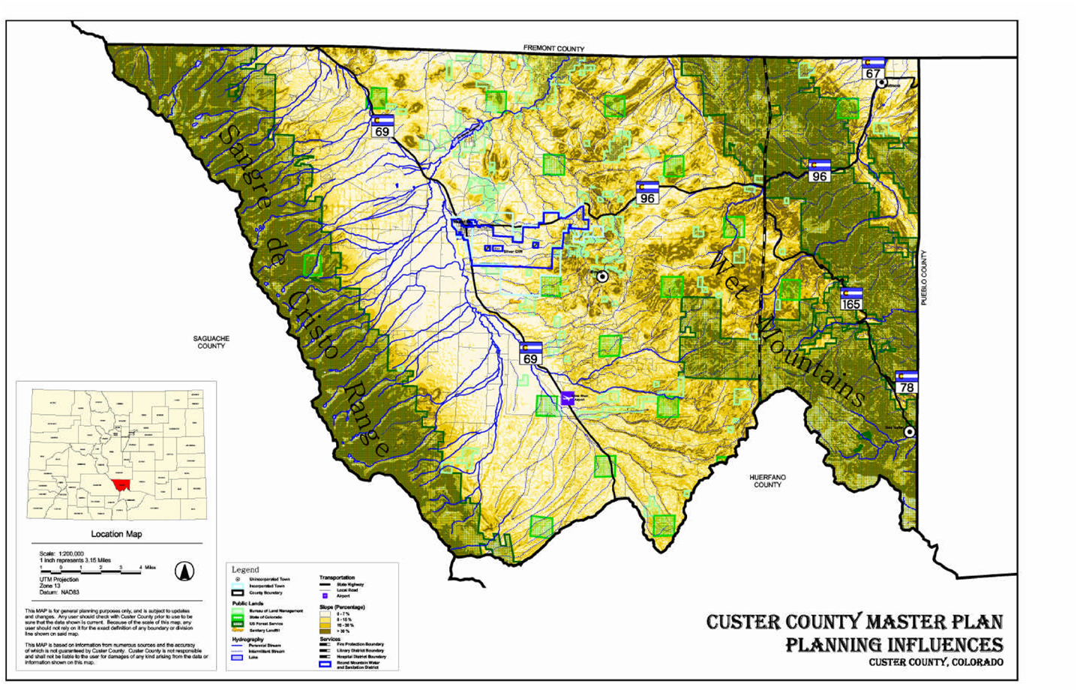
Figure 2. Planning Influences Map

Plan Direction

PLANNING AREAS

The Master Plan consists of six planning areas, five of which have distinct physiographic features and are geographically consistent with the unincorporated Custer County zoning districts as originally adopted in 1971. The six planning areas are shown on the Plan Direction map and described as follows:

Grape Creek Planning Area

The Grape Creek Planning Area is located in the Wet Mountain Valley, generally due west of Westcliffe, SH 69 and Grape Creek, and corresponds to the original Zoning District I: Grape Creek District. The Grape Creek Planning Area is generally a rich alluvial environment intended to have a low population density and to remain agricultural in character.

Grape Creek Planning Area Directions:

- Land use should be primarily agricultural and ranching.

- Commercial or industrial uses associated with agricultural operations should be considered through the Special Use Permit process.

- Potential sand and gravel development should be subject to local control through the 1041 regulatory process or other special County regulations.

- Minimum lot sizes of 80 acres for primary residential dwelling units should be maintained.
Sangre De Cristo Planning Area

The Sangre De Cristo Planning Area is located west of the Grape Creek Planning Area in the Wet Mountain Valley and along the Sangre De Cristo Range, extending to the western county boundary, and corresponds to the original Zoning District II: Sangre De Cristo District. The Sangre De Cristo Planning Area is generally a high mountain environment with substantial public lands and agricultural and residential uses.

Sangre De Cristo Planning Area Directions:

- Land use should be primarily agricultural, forestry, rural residential and recreational.

- Commercial or industrial uses associated with agricultural, forestry and recreational operations should be considered through the Special Use Permit process.

- Minimum lot sizes of 35 acres for primary residential dwelling units should be maintained.

Wet Mountain Planning Area

The Wet Mountain Planning Area is located east of the Foothills Planning Area, in the Wet Mountains generally extending

to County Road 387 and the eastern boundary of the San Isabel National Forest, and corresponds to the original Zoning District III: Wet Mountain Zoning District. The Wet Mountain Planning Area is generally a forested mountain environment with substantial public lands and limited agricultural and residential uses.

Wet Mountain Planning Area Directions:

- Land use should be primarily agricultural, forestry, rural residential and recreational.
- Commercial or industrial uses associated with agricultural, forestry and recreational operations should be considered through the Special Use Permit process.
- Minimum lot sizes of 10 acres for primary residential dwelling units should be maintained.
- Commercial uses, and residential uses with minimum lot sizes less than 10 acres, should be considered in the community of San Isabel and the existing small lot subdivisions in the San Isabel area, through the Special Use Permit process. Minimum lot sizes of 100 feet x 150 feet are recommended in the San Isabel area, with a well and an engineered septic system.
- Due to the density in the San Isabel area, the feasibility of developing community water and sewer systems should be investigated.

Foothills Planning Area

The Foothills Planning Area is located in portions of the Wet Mountain Valley and the Wet Mountains, between the Wet Mountain Planning Area and the Grape Creek Planning Area, and corresponds to the original Zoning District IV: Foothills Zoning District. The Foothills Planning Area is generally a sage-covered environment with numerous approved subdivisions and residential uses.

Foothills Planning Area Directions:

- Land use should be primarily agricultural, forestry, mining, rural residential and recreational.
- Commercial or industrial uses associated with agricultural, forestry, mining, or recreational operations should be considered through the Special Use Permit process.
- Minimum lot sizes of 5 acres for primary residential dwelling units should be maintained.
- Commercial uses, and residential uses with minimum lot sizes less than 5 acres, should be considered in the Town site of Rosita and the existing small lot subdivisions in the Rosita area and Lake De Weese area, through the Special Use Permit process. Minimum lot sizes of 100 feet x 150 feet are recommended in the Rosita area and the Lake De Weese area with a well and an engineered septic system.
- Due to the density in the Town site of Rosita and the existing small lot subdivisions in the Rosita area and Lake De Weese area, the feasibility of developing community water and sewer systems should be investigated.
Hardscrabble Planning Area

The Hardscrabble Planning Area is located east of the Wet Mountain Planning Area extending to the eastern county boundary.

The Hardscrabble Planning Area corresponds to the original Zoning District V: Hardscrabble Zoning District. Zoning District V has been integrated into Zoning District III, and no longer exists. The Hardscrabble Planning Area is generally high plains and rolling terrain with concentrated development in the Wetmore area.

Hardscrabble Planning Area Directions:

- Land use should be primarily agricultural, rural residential and recreational.
- Commercial or industrial uses associated with agricultural and recreational operations should be considered through the Special Use Permit process.
- Potential oil and gas development, especially coal-bed methane extraction, should be subject to local control through the 1041 regulatory process or other special County regulations.
- Minimum lot sizes of 10 acres for primary residential dwelling units should be maintained.
- Commercial uses, and residential uses with minimum lot sizes less than 10 acres, may be appropriate in the community of Wetmore and the existing small lot subdivisions in the Wetmore area, through the Special Use Permit process. Minimum lot sizes of 100 feet x 150 feet are recommended in the Wetmore area with a well and an engineered septic system.
- Due to the deep water table in the Wetmore area, the feasibility of developing a community water system should be investigated.

Cooperative Planning Area

The Cooperative Planning Area contains the primary growth centers for the County, where urban services are available or may become available. The Cooperative Planning Area corresponds to the incorporated towns of Silver Cliff and Westcliffe and their future growth areas.

Cooperative Planning Area Directions:

- An intergovernmental agreement should be negotiated and updated as appropriate to address inter-jurisdictional planning issues, such as coordinated development review, annexation impacts, future road connections, and mutual service provision.
- With annexation of unincorporated land to either Town, the Cooperative Planning Area boundaries should be updated.
- Decisions on future land use and growth within the Cooperative Planning Area should be guided by the Town of Silver Cliff Master Plan, the Town of Westcliffe Master Plan, and the respective zoning, subdivision, and other development regulations for each Town.

ENVIRONMENT

Environment Goals:

To protect Custer County’s natural, environmental and scenic resources, maintaining wildlife diversity, forest health, and access to public lands for current and future generations.

Environment Policies:

- The County should encourage preservation of unique, sensitive or critical natural areas, lakes and streams, scenic vistas, wildlife habitats and aquifer recharge areas.
- The County should encourage the preservation, conservation and retention of all water resources.

- The County should encourage the protection of all mineral resources while ensuring that the impacts of extraction activities are mitigated.

- The County should encourage the protection of all forestry resources while ensuring that the impacts of timbering activities are mitigated.

- The County should encourage development practices in environmentally sensitive or constrained areas that promote the general health, safety and welfare of its residents and visitors without infringing on individual rights.

Environment Actions:

- Create incentives, such as special use allowances in exchange for site sensitive development, to preserve open space and foster land stewardship of both open and developed land.
Timeframe: On-going

- Work with the Division of Wildlife, community groups and others to identify opportunities to preserve open space around wildlife habitat and migration corridors.
Timeframe: Mid-term

- Develop a hydrological study in cooperation with the United States Geological Survey to determine the availability, quality and quantity of water in Custer County.
Timeframe: Ongoing

- Explore strategies with the Upper Arkansas Water Conservancy District, water right owners and other stakeholders for retaining the use of water within Custer County.
Timeframe: Short-term

- Develop a Mineral Resource Plan for the extraction of commercial mineral, sand and gravel deposits.
Timeframe: Mid-term

- Prepare local regulations addressing matters of statewide interest (1041 regulations) for mineral resource areas to address potential future coal bed methane gas extraction and sand and gravel extraction.
Timeframe: Mid-term

- Work with the United States Forest Service, the Bureau of Land Management, the Colorado State Forest Service, Colorado Division of Wildlife, and other agencies to prepare wildland fire hazard mapping.
Timeframe: Mid-term

- Update the Zoning Resolution and Subdivision Regulations, as appropriate to address development activities in environmentally constrained areas, such as on steep slopes, in wildlife corridors and wildfire hazard areas, and areas with adverse soil properties.
Timeframe: Mid-term

- Work with the United States Forest Service, the Colorado State Forest Service, Bureau of Land Management, Colorado Division of Wildlife, and other agencies to utilize their knowledge and resources to keep informed on Custer County’s environmental health.
Timeframe: Ongoing

Land Use Goals:

To preserve Custer County's "rural" character traits - the existing agricultural economy; open space; scenic vistas; forestry and mining - through desired physical development and economic growth without infringing on property rights.

To support development of a stable, diversified, year-round economic base, as a sustainable economy is a necessary ingredient for the well-being of Custer County now and in the future.

Land Use Policies:

- The County should consider environmental and fiscal impacts of development proposals.

- The County should consider land protection techniques and site development options to maintain agricultural lands, forests, and open space.

- The County should consider land protection techniques and site development options to maintain agricultural lands, forests, and open space.

- The County should support the retention, expansion and recruitment of businesses which are consistent with the quality of life Custer County citizens’ desire.

- The County should direct commercial and industrial development into appropriate areas, with consideration for the type and impact of specific uses.

- The County should discourage any development, excluding agricultural operations, adjacent to water courses; on productive ranch lands, particularly on hay meadows; in areas of demonstrated wildlife habitats; and in areas which would cause damage to significant natural features.

- The County should encourage energy conservation in all phases of growth and development.

- The County should encourage the development of housing available to persons of all income levels.

- The County should create standards and procedures for the location, design and construction of secondary dwelling units.

Land Use Actions:

- Update the Subdivision Regulations to:

- Incorporate a review process consistent with Planned Unit Developments.

- Provide submittal requirements that address overall impact as part of the approval process.

- Require that a water supply of adequate quantity and quality be available to support the intended use and fire protection needs.

- Require new developments to install utilities underground.

- Provide incentives, such as a Minor Subdivision review process, to consolidate lots that are smaller than the minimum lot size required into larger lots.

- Provide alternatives to traditional developments patterns, such as clustering and other site-sensitive platting techniques.

- Update definitions.

- Provide guidelines for weed control and wildfire prevention.

- Update provisions to be consistent with current case law and statutes.

Timeframe: Short-term

- Update the Homeowner’s Packet to:

- Provide guidelines on what constitutes quality residential development.

- Provide information on alternative energy and energy conservation practices.

Timeframe: Short-term

- Update the Zoning Resolution to:

- Specify what type of residential, Commercial, industrial and recreational uses are appropriate to be considered for Special Use Permits in specific zoning districts, and the conditions for mitigating any adverse impacts.

- Create review procedures for secondary dwelling units and specify the criteria for each zoning district.

- Require new commercial and industrial development to address aesthetic issues, such as, landscaping, architectural design, and screening.

- Create overlay districts to promote infill development and reduce the number of non-conforming lots, structures and uses by allowing dwelling units on existing residential lots less than the minimum lot size required, in Wetmore, Rosita, San Isabel and the Lake De Weese area.

- Determine the legal/regulatory requirements for the creation of an Airport Protection Overlay District

Timeframe: Short-term
- Work with community groups and individuals to encourage the use of fully-shielded (no light emitted above the horizontal plane of the fixture) street and utility lights, without jeopardizing safety or creating unnecessarily high energy use.
Timeframe: On-going

- Work with the Colorado Historical Society, community groups and individuals to preserve and maintain historic and archaeological sites.
Timeframe: Long-term

- Establish a community Economic Development Committee.
Timeframe: Short-term

- Work with the State agencies and telecommunication utilities to provide facilities for high-speed digital data transmission, and to include Pueblo in the local calling area for all Custer County telephone users.
Timeframe: On-going

- Work with property owners and others to replat parcels and offer land swaps, as appropriate in areas such as Rosita, the Lake De Weese area, and San Isabel, to improve the viability of developing irregular or non-conforming lots.
Timeframe: On-going

COUNTY SERVICES

County Services Goals:

To encourage cooperative planning between federal, state, county and local government, school districts, special districts, businesses and citizens, and ensure the long-term, adequate provision of services and infrastructure within Custer County.

County Services Policies:

- The County should encourage citizen participation, and assure them they can make a difference in government decision-making.

- The County should promote a safe and well-maintained road system, with access provided for emergency vehicles where feasible.

- The County should pursue initiatives that will decrease the amount of refuse deposited at the County Landfill to extend its life-cycle and better meet EPA requirements.

- Septage facilities operated in Custer County should be designed and operated in compliance with all applicable local, state and federal regulations.

- The County should support the use and expansion of libraries as places where people can meet, exchange information and learn.

- The County should encourage the creation of additional post high school and adult educational opportunities, including additional academic courses and vocational training, through mutual planning by the County, towns, school districts and businesses.

County Services Actions:

- Develop an intergovernmental agreement that addresses coordination of land use issues between the County and the incorporated towns of Silver Cliff and Westcliffe.
Timeframe: Short-term

- Periodically review policies, resolutions, ordinances and programs to assure that they are consistent with each other and with community goals.
Timeframe: On-going

- Develop a Capital Improvement Program that establishes funding priorities and specific improvements of public facilities, including physical access to public buildings, which are viewed as desirable or needed by the citizens.
Timeframe: Mid-term

- Develop and implement a Geographic Information System (GIS).
Timeframe: Ongoing

- Develop a long-range transportation plan that specifies future County road improvements.
Timeframe: Mid-term

- Identify roads by name and number with signs in a consistent manner throughout Custer County.
Timeframe: Mid-term

- Work with private haulers and local citizens to support a cost-effective Recycling Center.
Timeframe: Short-term

- Investigate the feasibility of developing community water and sewer systems in Wetmore, San Isabel, Rosita and the Lake De Weese area.
Timeframe: Long-term

- Develop a countywide Septage Waste Disposal Facility Plan.
Timeframe: Mid-term

- Work with public, private and not-for profit interests to provide opportunities for education and recreation for all citizens through a shared use of all available facilities.
Timeframe: Mid-term

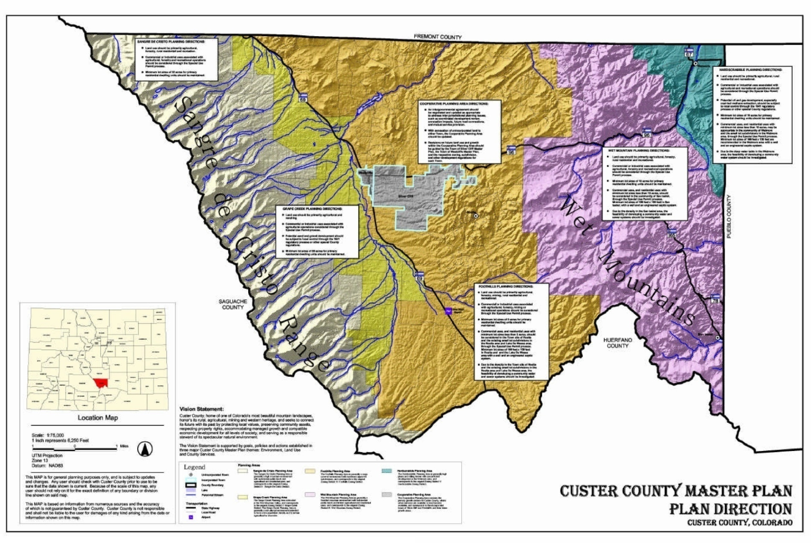
Figure 3. Plan Direction Map

Appendix A: Glossary of Planning Terms

Actions: Measures to implement the Master Plan and ultimately achieve a desired goal. Each action includes a timeframe for completion: short-term (one to two years); midterm (three to five years); long term (beyond five years), and on-going.

Capital Improvement Programming:
A schedule and budget for future road, building or other projects to be carried out over a specified period of time.

Density: The number of dwelling units per unit of land.

Dwelling Unit: A building designed to be used as a full or part-time living place.
Easement: Authorization for use of land for a specific purpose.

Goals: The broad objectives to be achieved by the Master Plan.

Infill Development: Development of vacant lots within an existing townsite or subdivision.

Intergovernmental agreement (IGA): An agreement between governmental entities for achieving coordinated planning and the efficient provision of services.

Master Plan: A plan adopted by the Custer County Planning Commission pursuant to C.R.S. Section 31-23-201, et seq.; Also known as a Comprehensive Plan or General Plan.

Overlay District: A special zoning district with standards for a particular type of use or area.

Plan Direction: A map that identifies the six Planning Areas.

Plan User’s Workbook: A practical guide for using the Master Plan that includes a reference guide, a project evaluation checklist, and a summary of goals, policies, and actions.

Planned Unit Development (PUD):
A unified plan of development which does not correspond to traditional zoning or subdivision standards.

Planning Area: An area identified on the Plan Direction.

Plat: A document, prepared by a Colorado registered engineer or surveyor in accordance with subdivision regulations or current zoning resolution.

Policies: Guidelines for decision-making.
Rural Residential: Dwellings located on subdivided lots ranging from five (5) acres to eighty (80) acres in size.

Septic System: An approved method of waste disposal comprised of all of the components necessary for full functionality.

Special Use Permit (SUP): A use allowed with permission of the County Commissioners.

Zoning District: A zone shown on the County’s zoning map for which there are regulations governing the use of that land.

Appendix B: Bibliography

Draft Custer County Master Plan; Custer County; August 2000.

Draft Custer County Master Plan;
Custer County Regional Planning Commission; April 2000.

Draft Custer County Master Plan – Preliminary Draft;
Custer County Master Plan Committee; 1997.

Draft Custer County Area Plan and Regulations;
Vandegrift & Associates; 1984.

Draft Custer County Comprehensive Plan;
Upper Arkansas Area Council of Governments; 1975.

Custer County Sketch Plan; Colorado State Planning Office; 1969.

Master Plan; Town of Silver Cliff; 2002.

Master Plan; Town of Westcliffe; 2000.

Custer County Alternative Growth Futures Project;
University of Colorado at Denver; 2001.

Keep Custer County Special – Custer County Community Forum;
Sonoran Institute; 1999.

Custer County, Colorado - Measure Today Insure Tomorrow;
Custer 2020; 1999.

Draft Subdivision Regulations; Gorsuch Kirgis; 2002.

Preliminary Review of Subdivision Regulations; Gorsuch Kirgis; 2002.

Subdivision Regulations; Custer County; 1973.

Zoning Resolution; Custer County; 1995, 2002.

Zoning and Subdivision Resolution Diagnosis; Clarion Associates; 2000.

Homeowner’s Packet; Custer County; 2001.

Establishing A Right To Ranch and Farm Policy; Custer County; 1998.

Selected Subdivision Buildout; Custer County; 2001.

Zoning and Septic Permits Issued: 1994-2001; Custer County; 2001.

Budget Message 2002; Custer County; 2001.

The Cost of Rapid Growth; San Isabel Foundation, et. al; 2000.

The Cost of Community Services in Custer County, Colorado; Haggerty, Mark; 2000.

Feasibility Report Summary; Trust For Public Land; 2000.

Custer County Overview; Upper Arkansas Area Council of Governments; 2001.

Real Estate Abstract by Land Use Code; Custer County; 2001.

Abstract of Assessment; Custer County; 2001.

Profile of General Demographic Characteristics: 1990-2000; U.S. Census Bureau; 2001.

Regional Accounts Data; U.S. Bureau of Economic Analysis; 2000.

County Profile of Custer County; Custer 2020; 1996.

Soil Survey of Custer County Area, Colorado; U.S. Department of Agriculture; 1981.

School Accountability Report; Custer County School District C-1; 2001.

Dataset – Roadway Statistics; Colorado Department of Transportation; 2001.

Dataset – AADT Volumes; Colorado Department of Transportation; 2001.

Beanpole Project and Digital Divide-A Fact Sheet;
Colorado Office of State Planning and Budgeting; 2001.

Soil Survey of Custer County Area, Colorado; U.S. Department of Agriculture;1981.

2002 Budget Message; Round Mountain Water & Sanitation District; 2001.

Annual Drinking Water Quality Report;
Round Mountain Water & Sanitation District; 2001.

To Our Customers; Round Mountain Water & Sanitation District; 2000.

Protecting Water For The People; Upper Arkansas Water Conservancy District; 2001.

Personal Communication; Bob Senderhauf,
Upper Arkansas Water Conservancy District; 2002.

Upper Arkansas Enterprise Zone EZ Facts; Colorado Department of Revenue; 2000.

Custer Chapter of the Fremont-Custer Historical Society (brochure); 2000.

Wet Mountain Tribune – Assorted Articles; Dec. 2001- April 2002.

CusterGuide.com website

Appendix C: Adoption Resolution

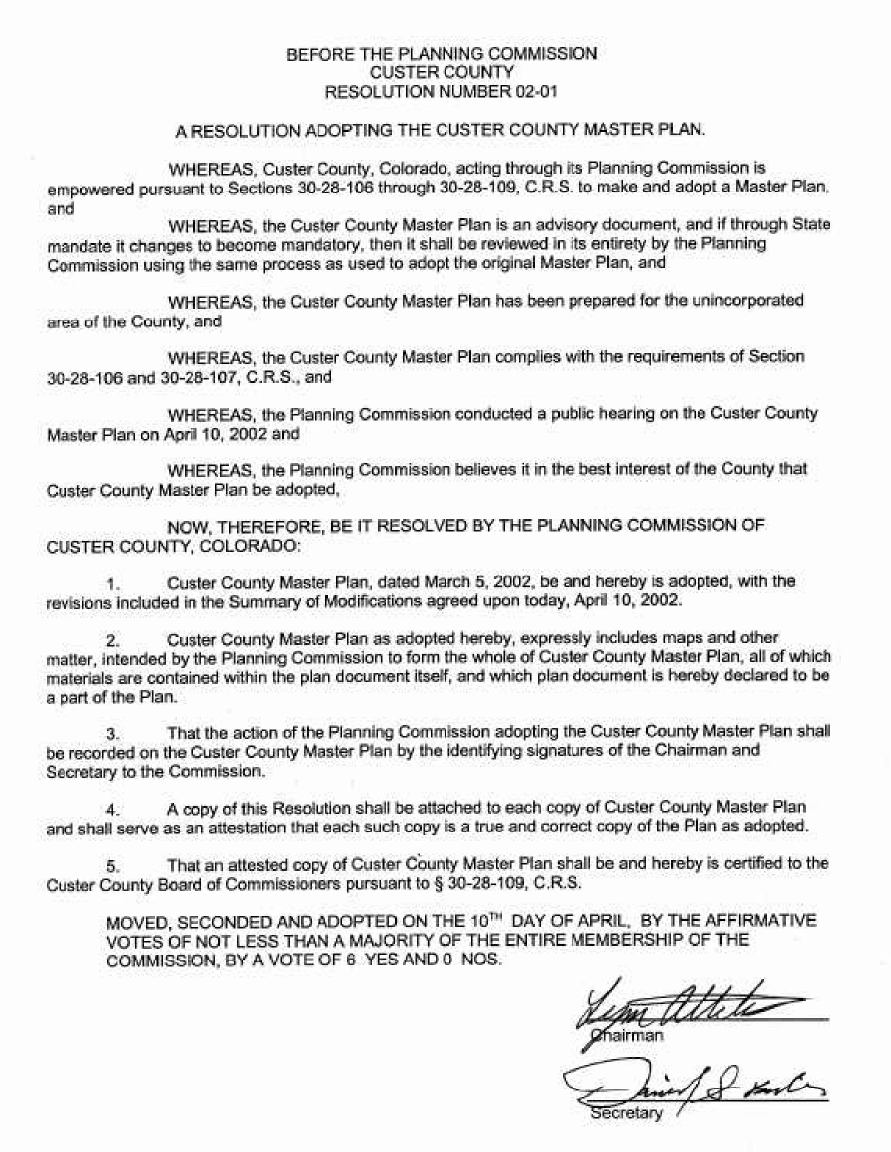

Acknowledgments

STEERING COMMITTEE

Custer County Board of County Commissioners
Dale Hoag, Chair
Dick Downey
Larry Handy

Custer County Planning Commission
Lynn Attebery, Chair
Pat Bailey
Vic Barnes
Alden Gray
Keith Hood
Sherry Rorick

Custer County Board of Zoning Adjustment
Bill Donley, Chair
Rob Canterbury
Peter Lo Presti
Dorothy Nepa
Art Solomon

Associate Members
Jim Austin
Robyn Canda
John Campbell
Skip Northcross
Gary Roberts
Selby Young

Custer County Staff
Linc Lippincott
Dan Bubis
Christy Kesselring

Photo Credit
Christy Kesselring
SPECIAL THANKS TO:
Marty Frick, W. Custer County Library District
JD Henrich, Custer County Assessor’s Office
Kelly Camper, Custer County Assessor’s Office Charlie French, Custer County Cartographer
Elizabeth French, Custer County Planning and Zoning Office
Sue Hutton, Town of Silver Cliff Administrator
Jim Little, Wet Mountain Tribune
Pete Michaelson, Silver Cliff Town Attorney
John Naylor, Custer County Attorney
Bud Piquette, Round Mountain Water and Sanitation District
Bob Senderhauf, Upper Arkansas Water Conservancy District Representative
Kit Shy, County Surveyor
Paul Snyder, Westcliffe Town Attorney
Don Stuart, Town of Westcliffe Manager
Bob Thomason, Creative Minds
The Wetmore Community Center
...and everyone who worked toward the completion of Custer County’s first adopted Master Plan!

PLANNING TEAM
MJ Landers & Associates, Inc.
Martin Landers, AICP, Project Director

Balloffet-Entranco
Daniel Lambert, Landscape Architect
Robert LeClair, GIS Coordinator
Marion Freymann, Graphic Artist

Gorsuch Kirgis LLP
Gerald Dahl, Esq., Land Use Attorney
TerraSmith Consulting
David Smith, GIS Technician
Contract Support Services
Sue Marshall, Project Coordinator

